June
2022  - Digital Skills- History and Future-Tech in our Everyday Lives  - Leading on and off the Field-Sportsmanship  - Client Appreciation | 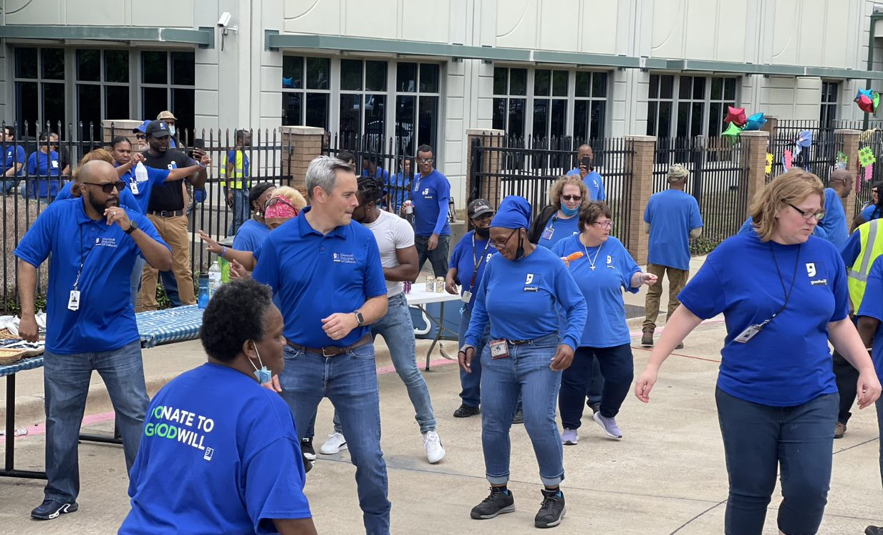
Sunday | Monday | Tuesday | Wednesday | Thursday | Friday | Saturday
 |  |  | 1 | 2 | 3 | 4
 |  |  |  | Digital Skills Training
5 | 6 | 7 | 8 | 9 | 10 | 11
Field Trip
Frisco Discovery Center

12 | 13 | 14 | 15 | 16 | 17 | 18
 |  |  | Client Appreciation | Denton Store  Grand Opening
19 | 20 | 21 | 22 | 23 | 24 | 25
 |  |  |  | Digital Skills Training
26 | 27 | 28 | 29 | 30
 | Games Week |  |  | Field Day Events
Digital Skills:  Provide clients with an opportunity to learn how to use computers and other communication technology.  Digital Skills Lab Hours:  Monday -Thursday  9:00 AM - 2:00 PM | Client Field Trip:  Frisco Discovery Center  Video Game Museum  8004 Dallas Pkwy, Frisco, TX 75034  Friday, June 10, 2022  9:00 AM – 1:00 PM | Client Appreciation:  Each year we recognize clients for their employee contributions to the workplace and programs. | Games Week:  June 27th -30th (Indoor)  Field Day:  June 30, 2022 (Outdoor)  11:30 AM - 2:30 PM  (Weather Permitting)

